ABC Pharmacy  
Business capability analysis and data model

12/15/2019

# Executive summary

## Overview

This document provides results on the data analysis performed on the historical data for ABC pharmacy, describes the data model associated, findings and business opportunities. It provides product performance across spectrum of product portfolio as well store performance across various states.

## Business Goals

* Identify investment opportunities on the products that are performing, so as to increase the quality of those products. Maintain appropriate inventory and adjust the supply and demand of the products.
* Identify the seasonality associated with any products so that appropriate stocks can be maintained.
* Sales revenue prediction and set appropriate sales targets.
* High and low performing stores
* Better business decisions based on historical data.

## Data Description

Data provides insights in the following for ABC Pharmacy

* Major product categories, product categories, products sub categories, product segments and finally product.
* Pharmacies across various states
* Sales transactions for various products and across pharmacies.

## Methodological summary

## Results

* Data Span across 6 months from Jan 2016 to June 2016
* Sales is restricted to only 6 states NJ,PA,NY,CT,MA,ME,DE
  + NJ State has highest sales revenue of $6,413,468.42
  + DE has lowest sales revenue of $7,050.33
  + Other states where there are stores do not generate any revenue, these states include PR, RI, NH, VI, VT
  + There are 991 stores across all states that do not generate any sales revenue, so are probably closed or not operatonal.
* Sales revenue maximum in March 2016 of $3,707,182
* Top 3 Products by Quantity

|  |  |
| --- | --- |
| Product | Quantity |
| DME SALES | 32583 |
| GENERICQS1ITEM | 21352 |
| VITAMINS/SUPPLEMENTS | 19201 |

* Top 3 Products By Sales Amount

|  |  |
| --- | --- |
| Products | Sales Value $ |
| MONEY ORDER | $ 1,662,010.26 |
| VITAMINS/SUPPLEMENTS | $ 756,299.96 |
| STRUTZ PRO | $ 745,804.90 |

* Top 3 Pharmacy stores by sales revenue

|  |  |
| --- | --- |
| Pharmacy Store | Pharmacy Sales Revenue $ |
| GNP PHARMACY #453 | $ 2,116,067.26 |
| GNP PHARMACY #200 | $ 1,743,900.83 |
| GNP PHARMACY #680 | $ 1,701,263.19 |

## Recommendations

# Core report

## Overview

This report provides the insights on the data analysis performed on the data of ABC pharmacy which includes their sales transactions from Jan to June 2016. It articulates business goals and questions associated with those goals as well as how data can help in achieving the business goals. Based on data analysis it provides recommendations for additional business opportunities and how the losses can be minimized. Based on the historical trends, patterns ABC pharmacy would be able to make appropriate predictions for future. It provides product and store performance which could critical for success of the business in future.

## Business goals

* Investments on type of products
  + Identify investment opportunities on the products that are performing exceptionally well, so as to increase the quality of those products.
* Adjust demand of supply of high volume products
  + Maintain appropriate inventory and adjust the supply and demand of the products.
  + Identify the seasonality associated with any products so that appropriate stocks can be maintained.
* Sales Revenue Targets
  + Sales revenue prediction and set appropriate sales targets for stores
* Store Performance
  + High and low performing stores
  + Identify geographically which states have higher sales revenue and which have lower.
* Total sales revenue for 6 months of transactions.

## Business questions

1. What’s total sales revenue for ABC Pharmacy for Jan 2016 to June 2016?
2. What’s percentage gain/loss in sales revenue every month for Jan 2016 to June 2016?
3. Which are the best-selling product?
4. Which major product categories perform better?
5. Are some products categories getting sold in greater quantities based on seasonality?
6. What are the average number of products sold per order, per month?
7. What’s state wise sales revenue?
8. Which store has maximum performance based on sales revenue?
9. What’s average sale per store?
10. What are number of stores state wise?
11. Non Performing stores - If there is need to minimize the losses, then which stores ABC pharmacy should be closing? (Note: Stores with least sales revenue can be closed)
12. For any particular store which product generates maximum revenue?
13. For any particular store which product does not generate any revenue or least revenue?
14. For any particular store which month has maximum sales?

## Data description

## Data quality

* Overall data seems to be appropriate with appropriate and consistent data types.
* Duplicate check
  + Performed duplicate check for following and did not find any duplicates
    - MAJOR_PROD_CAT
    - PROD_CAT
    - PROD_SUB_CAT
    - PROD_SEG
    - PROD_MASTER
    - PHRMCY_MASTER
  + In POS_TRANS checked duplicates based on BSKT_ID, PROD_NBR, PHRMCY_NBR, there are duplicates based on that so added SLS_DTE, EXT_SLS_AMT and SLS_QTY as part of unique identifier.
* Sales quantity is POS_TRANS is negative which seems to be legit as they could be returns in the store.
* CSV file related to MAJOR_PROD_CAT had an empty column so had to clean it.
* From PROD_MASTER there is no need to have the below columns as they can be derived based on SEG_CD.
  + MAJOR_CAT_CD
  + CAT_CD
  + SUB_CAT_CD
* In Pharmacy master there is pharmacy which is assigned to state with State code = ‘Z’ which is invalid.

## Data model

Below is the data model for ABC pharmacy data

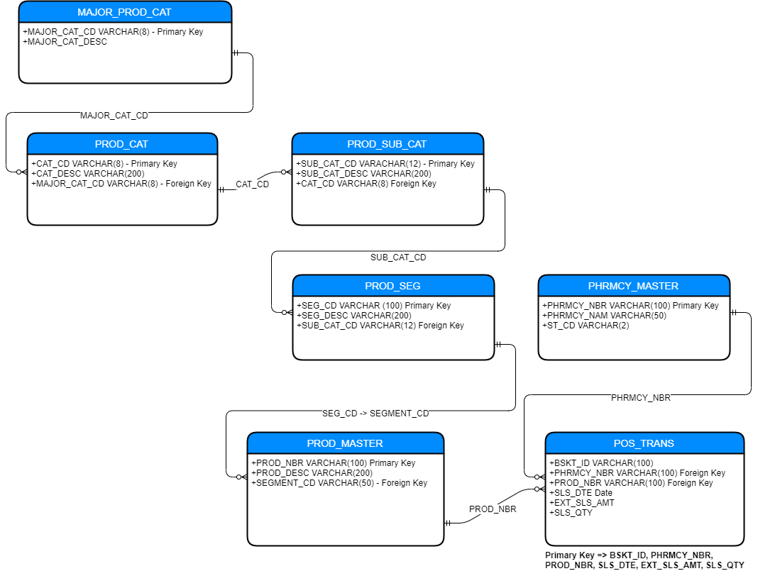

## Methodological summary

R has been used along with tidyverse package to answer majority of the business questions. For visualization have created charts using excel charts, alternatively can be created using R plotting libraries as well.

* For calculating total sales revenue for ABC pharmacy for Jan 2016 to June 2016 had to just sum the line item total for each order
* For percentage gain and loss month on month, first calculate the sales revenue for each month hand from Jan 2016 to June 2016 and then export data to excel and then use percentage calculation by subtracting current month minus previous month salary and diving it by previous month sales.
* For identifying top selling products by quantity had to group by product number and description and then do the sum of the sales quantity
* For identifying top selling products by $ value had to group by product number and description and then do the sum of the sales quantity multiplied by price each.
* For Product Categories performance joined transaction, product, product segment, product sub category, product category and product major category, and then grouped on Major product category and summed line item total which is sales quantity into sales amount.
* For identifying seasonality associated with major Product Categories joined transaction, product, product segment, product sub category, product category and product major category, and then grouped on Major product category, month and year of transaction date and summed line item total which is sales quantity into sales amount. Once the data is available export to csv and used excel to generate graphs and analysis.

## Results

### Total Sales revenue

* Total sales revenue for ABC Pharmacy from Jan 2016 to June 2016 is $17,283,853.00

### Percentage Gain/Loss month on month

Below table show the month on month sales

|  |  |  |
| --- | --- | --- |
| Month And Year | Monthly Sales $ | Month on Month Sales Revenue  (Increase/Decrease %) |
| Jan-16 | $ 3,026,923.89 |  |
| Feb-16 | $ 2,900,311.95 | -4% |
| Mar-16 | $ 3,707,182.09 | 28% |
| Apr-16 | $ 2,304,948.19 | -38% |
| May-16 | $ 2,523,208.54 | 9% |
| Jun-16 | $ 2,821,277.92 | 12% |

### Best Selling products

#### By Quantity

Below are 10 best-selling products quantity wise

|  |  |  |
| --- | --- | --- |
| PROD_NBR | PROD_DESC | PRODUCT_QTY_ORDER |
| 90400000000 | DME SALES | 32583 |
| 92000000000 | GENERICQS1ITEM | 21352 |
| 90800000000 | VITAMINS/SUPPLEMENTS | 19201 |
| 90300000000 | DME | 14580 |
| 99100000066590000000006 | CANDY OPEN DEPARTMENT | 14146 |
| 90600000000 | CARDS | 13323 |
| 1820025008 | 01820025008 | 12057 |
| 40003000753 | MIDWEST FASTENER | 11098 |
| 90900000000 | STAMPS | 10250 |
| 99100000120141000000010 | CANDY & BEVERAGE | 8708 |

#### By Sales Revenue

Below are 10 best-selling products by sales revenue

|  |  |  |
| --- | --- | --- |
| PROD_NBR | PROD_DESC | PRODUCT_VALUE_ORDER |
| 99100000770330000000003 | MONEY ORDER | $ 1,662,010.26 |
| 90800000000 | VITAMINS/SUPPLEMENTS | $ 756,299.96 |
| 98650000000000185441572 | STRUTZ PRO | $ 745,804.90 |
| 91000000000 | LOTTO | $ 480,597.98 |
| 98650000000000944904150 | WHEELED WALKER BRA/SEAT | $ 474,030.50 |
| 90400000000 | DME SALES | $ 472,319.23 |
| 79936677762 | GIFT CARD VISA $20-$500 | $ 426,615.30 |
| 92000000000 | GENERICQS1ITEM | $ 378,584.54 |
| 90600000000 | CARDS | $ 357,964.00 |
| 90300000000 | DME | $ 288,135.41 |

### Major Product Categories Performance

Below are the sales revenue by product categories

|  |  |
| --- | --- |
| **Product Categories** | **Sales Revenue $** |
| HEALTH CARE | $ 6,311,436.82 |
| GENERAL MERCHANDISE | $ 5,380,539.27 |
| HOME HEALTH CARE | $ 2,071,468.19 |
| GREETING CARDS | $ 1,115,704.89 |
| EDIBLES | $ 973,702.30 |
| PERSONAL CARE | $ 641,856.92 |
| BEAUTY | $ 378,114.97 |
| PHOTO | $ 211,492.51 |
| DIABETES | $ 172,144.30 |
| MISC | $ 27,392.41 |
| **Total** | **$ 17,283,852.58** |

### Seasonality associated with any major product category sales

Health care product category seems to be consistently higher is sales revenue, there is unusual spike in month of March 2016 where the sales revenue has jumped dramatically by $704,502.72

March month seems to highest sales revenue month with health care as major product category having maximum sales revenue, let’s see the products in that major category that performed better.

|  |  |
| --- | --- |
| PROD_DESC | March Sales Revenue |
| STRUTZ PRO | $ 486,103.66 |
| VITAMINS/SUPPLEMENTS | $ 241,266.68 |
| TEGADERM 4X4 3/4 1626 | $ 137,635.20 |
| ACIDOPHILUS SUPER PROBIO 5BILLN CAP 60CT | $ 54,624.93 |
| GNP U/PAD SPR 30X36 PAD 4X10 | $ 22,785.42 |
| GLOVE VINYL P/F L/F MD GLV 100 | $ 22,019.54 |
| SALONPAS PATCH HOT CAPSICUM UNS 50X1CT | $ 7,035.41 |
| FLORASTOR 250MG CAPSULE 50CT | $ 5,979.68 |
| GLOVE VINYL P/F L/F LG GLV 100 | $ 5,931.51 |

Now if we compare the above list with top 10 selling products by sales revenue, following are the products which are there in above but not in top 10 products list

* TEGADERM 4X4 3/4 1626
* ACIDOPHILUS SUPER PROBIO 5BILLN CAP 60CT
* GNP U/PAD SPR 30X36 PAD 4X10
* GLOVE VINYL P/F L/F MD GLV 100
* SALONPAS PATCH HOT CAPSICUM UNS 50X1CT
* FLORASTOR 250MG CAPSULE 50CT
* GLOVE VINYL P/F L/F LG GLV 100

So this does in indicate that is some seasonality pattern associated with some products.

### Averages

* Per Order average number of products sold = 2 products (1.82)
* Per Order average sale value = $27.8
* Per Month average number of products sold = 188661
* Per month average sales revenue = $2,880,642

### State wise sales revenue

|  |  |
| --- | --- |
| ST_CD | STATE_SALES_REVENUE |
| NJ | $ 6,413,468.42 |
| PA | $ 4,277,291.77 |
| NY | $ 2,733,151.59 |
| CT | $ 2,665,387.18 |
| MA | $ 798,851.27 |
| ME | $ 388,652.02 |
| DE | $ 7,050.33 |
| Total | $ 17,283,852.58 |

### Best Performing stores

Below are 10 best performing stores based on sales revenue

|  |  |  |
| --- | --- | --- |
| PHRMCY_NBR | PHRMCY_NAM | PHRMCY_NBR_SALES_REVENUE |
| 4416100399456673861 | GNP PHARMACY #453 | $ 2,116,067.26 |
| 2487426938853675539 | GNP PHARMACY #200 | $ 1,743,900.83 |
| 61520549788616420 | GNP PHARMACY #680 | $ 1,701,263.19 |
| 3009693108150153253 | GNP PHARMACY #269 | $ 1,437,316.97 |
| 2759406693434064370 | GNP PHARMACY #232 | $ 574,577.54 |
| 1174450154022548624 | GNP PHARMACY #18 | $ 522,080.09 |
| 6991356705459241502 | GNP PHARMACY #795 | $ 519,509.13 |
| 657046048504326744 | GNP PHARMACY #739 | $ 471,032.51 |
| 7003025686214903268 | GNP PHARMACY #798 | $ 412,827.33 |
| 8506230257184703229 | GNP PHARMACY #990 | $ 397,611.05 |

### Average Sale per store

Average Sales revenue per store is $163,055

### Number of Stores per State

|  |  |
| --- | --- |
| ST_CD | NUMBER_OF_STORES |
| NY | 390 |
| NJ | 288 |
| PA | 196 |
| PR | 97 |
| MA | 51 |
| CT | 42 |
| ME | 21 |
| DE | 4 |
| RI | 3 |
| NH | 2 |
| VI | 1 |
| VT | 1 |
| Z | 1 |

Even though following states have the stores, but there is no revenue generated from those stores which indicates that stores are probably closed down.

* PR
* RI
* NH
* VI
* VT

### Non Performing stores

1. Stores with no sales revenue
   1. There are 991 stores for which no revenue has been generated in span for Jan 2016 to June 2016
2. State wide stores with no revenue, which indicates which are not operational or closed

|  |  |
| --- | --- |
| ST_CD | NON_PERF_PHARMACY_COUNT |
| CT | 34 |
| DE | 3 |
| MA | 47 |
| ME | 10 |
| NH | 2 |
| NJ | 256 |
| NY | 374 |
| PA | 162 |
| PR | 97 |
| RI | 3 |
| VI | 1 |
| VT | 1 |
| Z | 1 |
| Total | 991 |

1. Below are 10 stores which have revenue of less than 10K, so in case if there is a need to minimize losses and closed certain stores then these stores could be the candidates

|  |  |  |
| --- | --- | --- |
| PHRMCY_NBR | PHRMCY_NAM | PHRMCY_NBR_SALES_REVENUE |
| 2109913237959930897 | GNP PHARMACY #150 | 100 |
| 1864727887909581358 | GNP PHARMACY #116 | 151.77 |
| 2557779967183367219 | GNP PHARMACY #211 | 260.98 |
| 7352666603740569574 | GNP PHARMACY #835 | 610.69 |
| 767790889581973829 | GNP PHARMACY #881 | 1075.47 |
| 4474219946559825502 | GNP PHARMACY #458 | 2100.6 |
| 7020056645499029586 | GNP PHARMACY #800 | 2420.52 |
| 8932873020424827010 | GNP PHARMACY #1053 | 3325.08 |
| 6456621789121903095 | GNP PHARMACY #725 | 4920.59 |
| 8146743720163240233 | GNP PHARMACY #942 | 6315.58 |
| 2460130771898242917 | GNP PHARMACY #196 | 6381.91 |
| 3204676104489970153 | GNP PHARMACY #297 | 7050.33 |
| 4754955394504903019 | GNP PHARMACY #500 | 9574.51 |
| 7872808829300808721 | GNP PHARMACY #902 | 9713.96 |

### For store which product generate max revenue

In this case we are going to consider the store with maximum sales revenue which is

|  |  |  |
| --- | --- | --- |
| PHRMCY_NBR | PHRMCY_NAM | PHRMCY_NBR_SALES_REVENUE |
| 4416100399456673861 | GNP PHARMACY #453 | $ 2,116,067.26 |

## Conclusions and recommendations